ASSIGNMENT - 4.2

2303A510G1
Batch : 30

Task Description-1
- Zero-shot: Prompt AI with only the instruction. Write a Python function to determine whether a given number is prime
Expected Output-1
- A basic Python function to check if a number is prime, demonstrating correct logical conditions without relying on examples or additional context

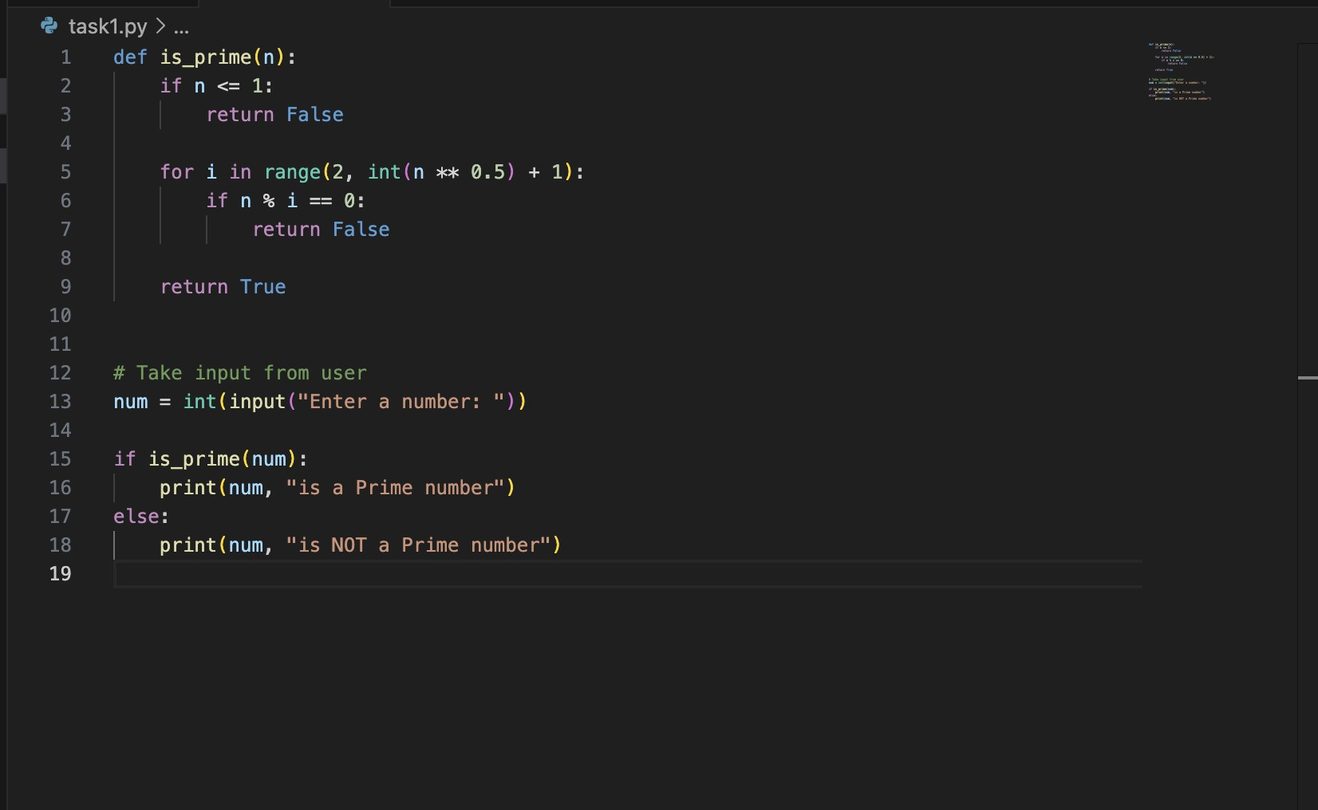

Output:

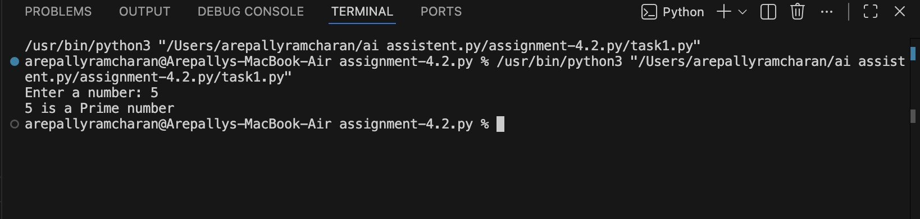

Observation:
  - AI generates a logically correct function based only on instruction.

  - Output is usually simple and straightforward.

  - May lack advanced optimizations unless explicitly requested.

  - Demonstrates that zero-shot works well for common problems.

Task Description-2
- One-shot: Provide one example: Input: [1, 2, 3, 4], Output: 10 to help AI generate a function that calculates the sum of elements in a list.
Expected Output-2
- A correct conversion function guided by the single example.

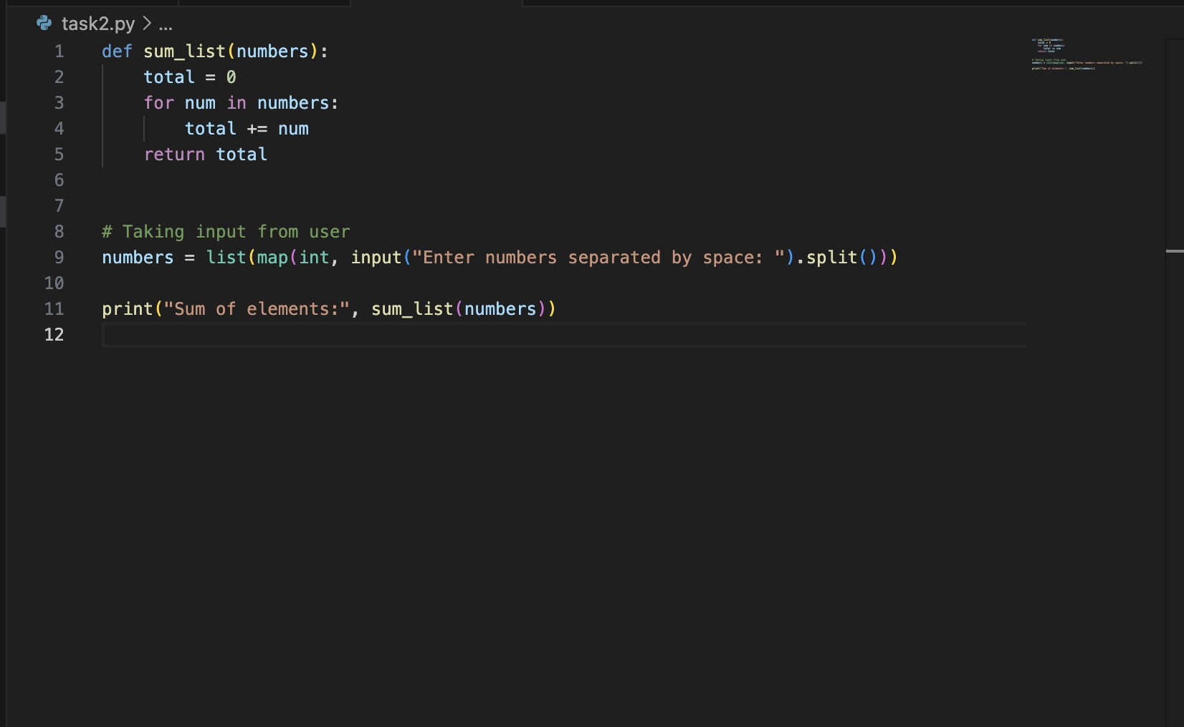

Output:

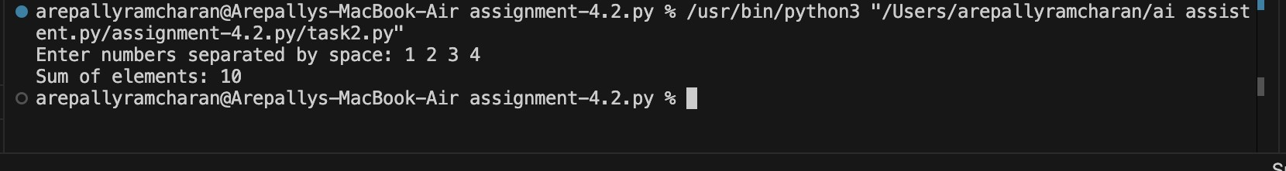

Observation:
  - Modular Design – One function handles multiple shapes, improving reusability. The single example helps AI clearly understand expected behavior.

  - Output format and logic align closely with the example.

  - Reduces ambiguity compared to zero-shot.

  - Produces more accurate and structured output.

Task Description-3
- Few-shot: Give 2–3 examples to create a function that extracts digits from an alphanumeric string.
Expected Output-3
- Accurate function that returns only the digits from alphanumeric string.

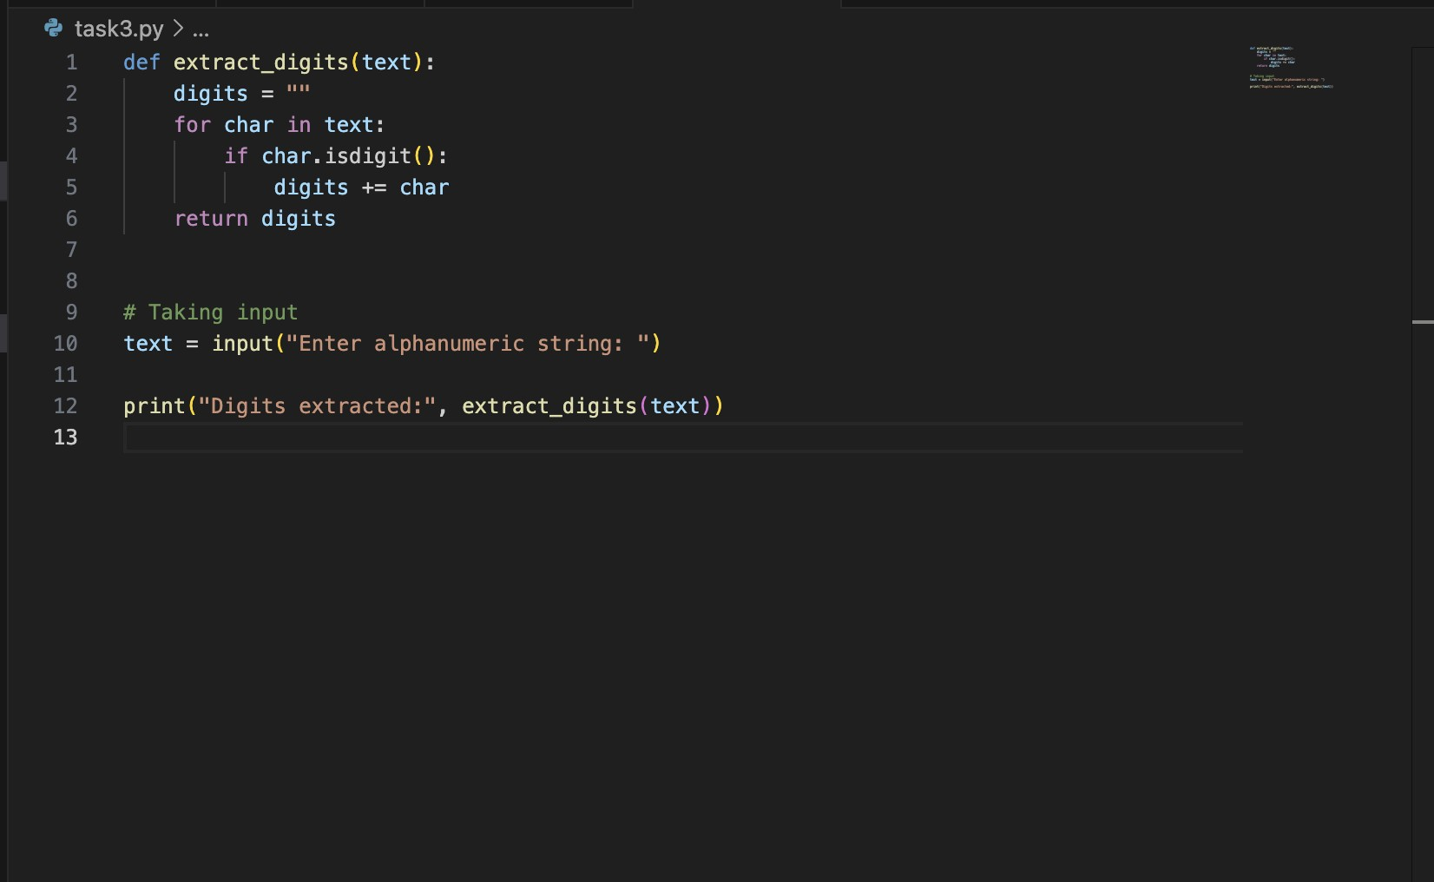

Output:
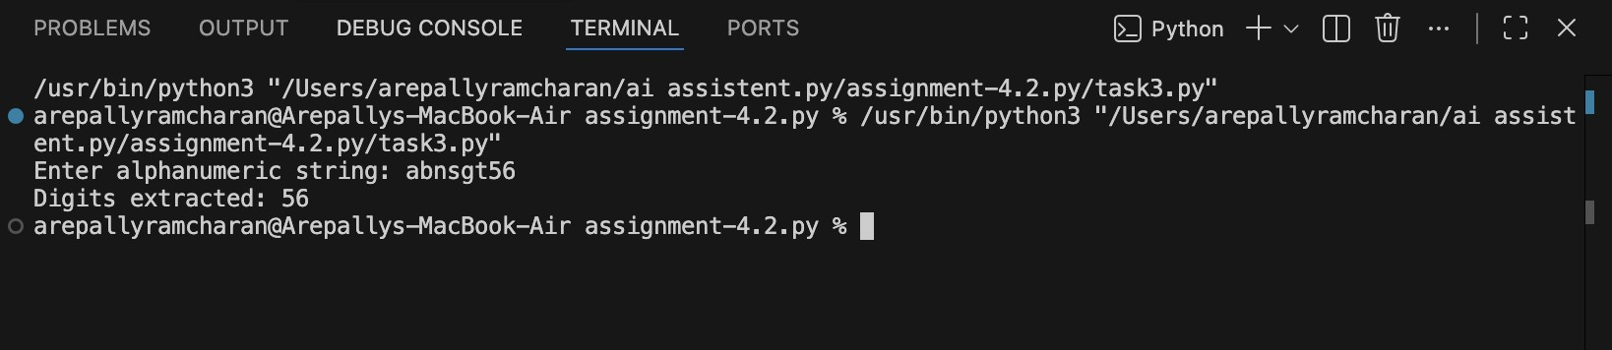
Observation:
  - Multiple examples improve pattern recognition.

  - AI correctly understands transformation logic.

  - Fewer logical errors compared to zero-shot.

  - Better handling of edge cases due to examples.

Task Description-4
- Compare zero-shot vs few-shot prompting for generating a function that counts the number of vowels in a string.
Expected Output-4
- Output comparison + student explanation on how examples helped the model.

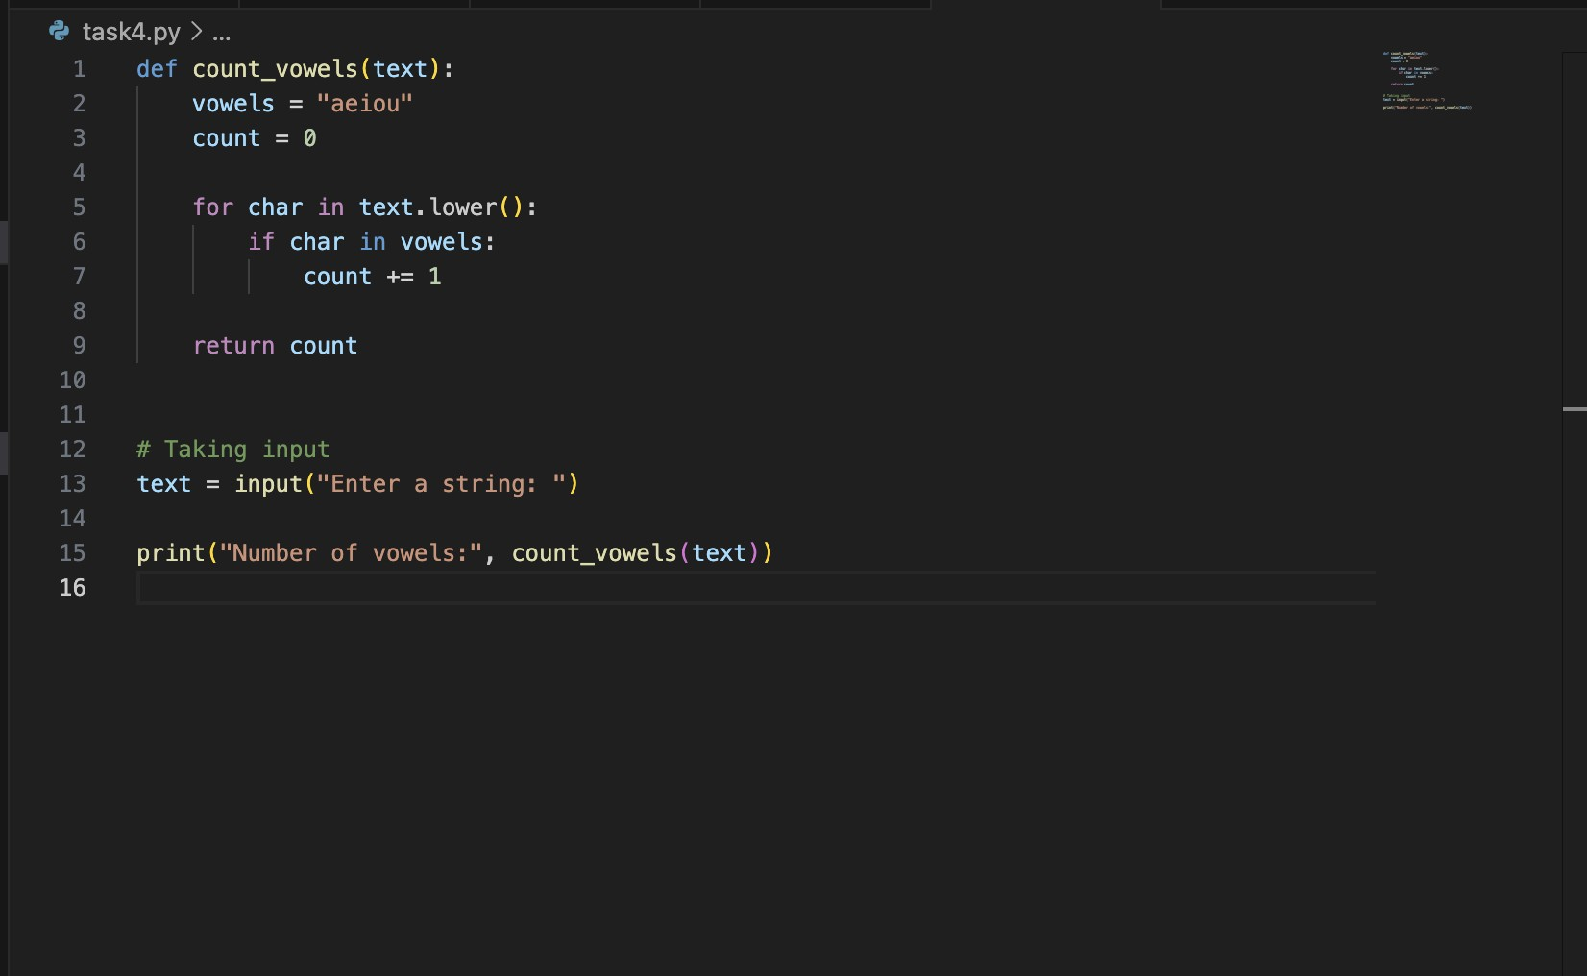

Output:
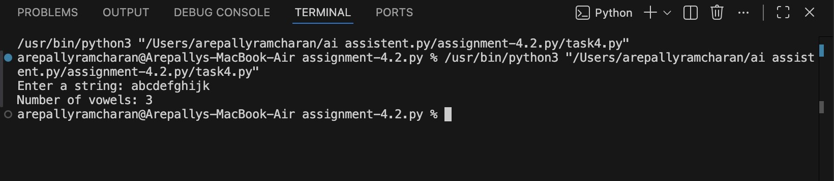
.

Observation:
  - Zero-shot gives general implementation.

  - Few-shot provides more consistent and accurate output.

  - Examples guide formatting and logic precision.

  - Few-shot reduces misunderstanding of requirements.

Task Description-5
- Use few-shot prompting with 3 sample inputs to generate a function that determines the minimum of three numbers without using the built-in min() function.
Expected Output-5
- A function that handles all cases with correct logic based on example patterns.

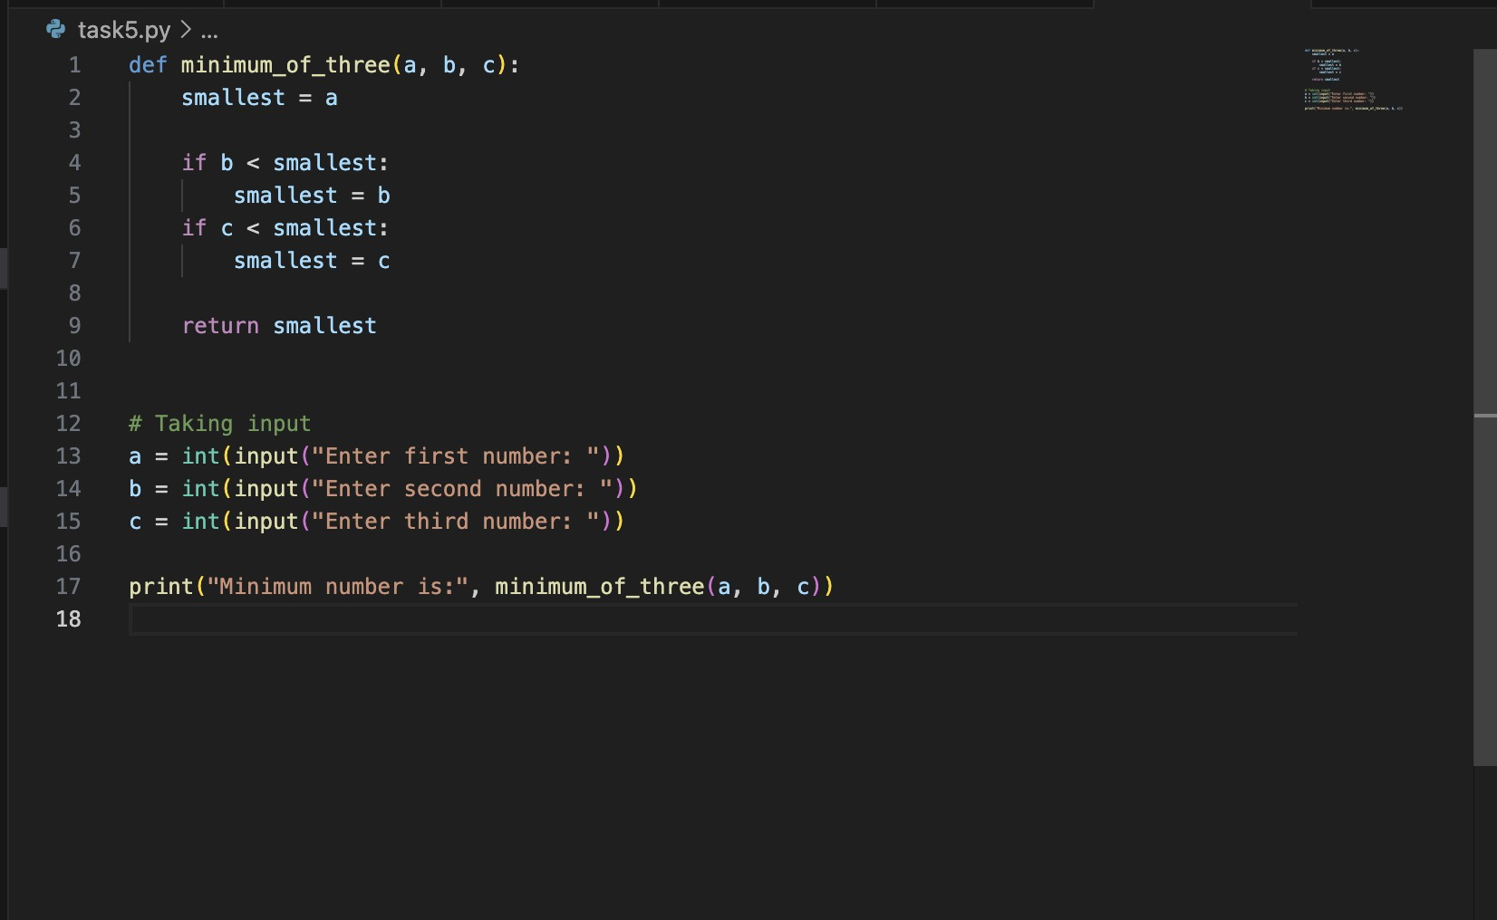

Output:

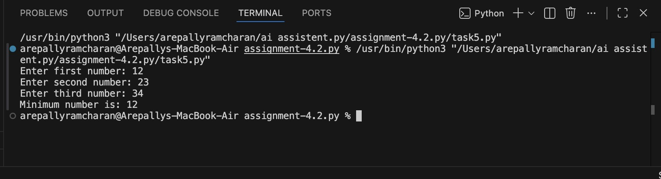

Observation:
  - Examples help AI infer comparison logic correctly.

  - Function handles different number order cases properly.

  - More reliable than zero-shot for conditional problems.

  - Demonstrates that examples improve logical consistency.

